**SPRINT 4**

**TEAM ID:** PNT2022TMID16894

**DATE:** 19-11-22

**PROJECT NAME:** REAL-TIME RIVER WATER QUALITY MONITORING AND CONTROL

**System SUMMARY:**

In the previous sprint, weather data is given only on entering the latitude and longitude.

Since one cannot expect the user to always look up for the coordinates, this sprint does the job for the user. Now the user can just type the city of interest and can get the data.

**CODE:**

**a) Node Red:**

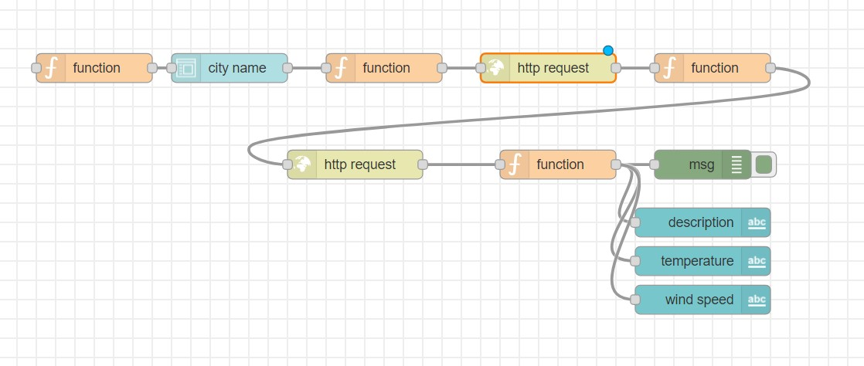

**b) MIT App Inventor:**

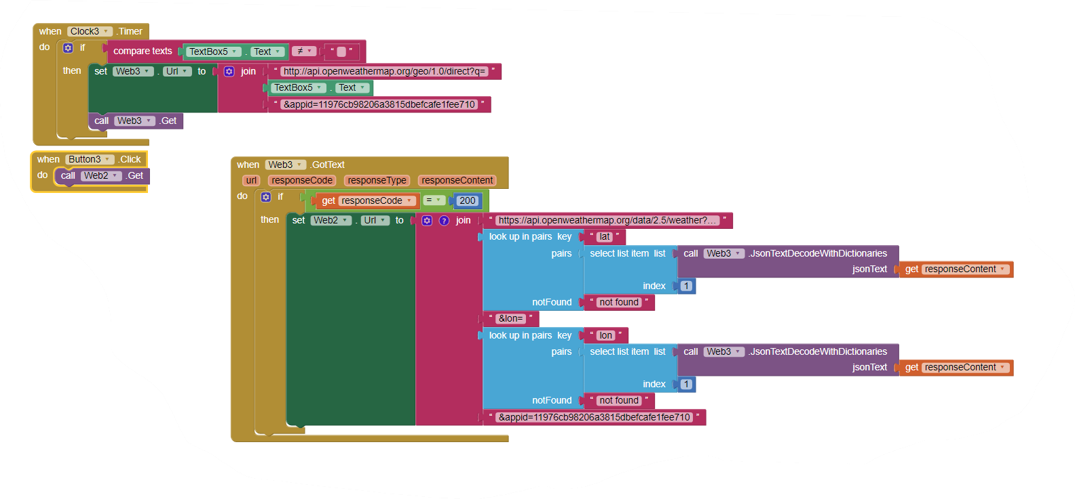

**OUTPUT:**

1. **Node Red:**

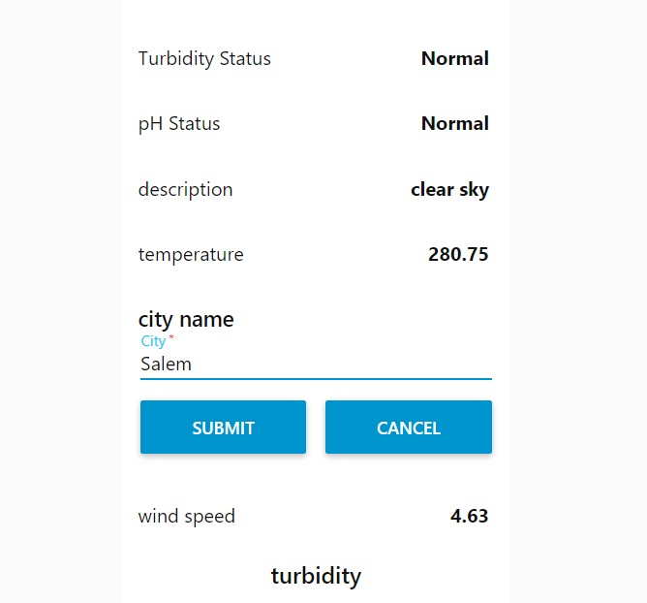

1. **MIT App Inventor:**

